**The Fuel Additives Development&Marketing is responsible for the technical and commercial development of performance chemicalsapplied to petroleum and petrochemical products as well as bio fuels.**

**Our first target is the development of additives which meet market requirements in terms of performance, quality and cost efficiency. To this end, we work in strict collaboration with our clients formulating, when necessary, tailored products and guaranteeing on-going technical and analytical support, including specific monitoring and predicting tools.**

**With more than 40 years of experience in this sector, we have introduced innovative chemicals to the market which are unique in their application field.**

**Meeting the new and emerging needs of the market has always been our main target. Recently we focused on the improvement of the safety in the workplaces, the protection of the environment and biofuels. We are the European company with the longest experience in the treatment of FAME.**

**Traditional Fuel Applications**

**Our product portfolio includes all types of chemical additives normally used to improve the quality and performances of fuels (gasoline, kerosene, diesel, bunker) and of other petroleum products (intermediates, bitumen, residue). Please contact us for further details. (**inserire [fueladditives@chimec.it](mailto:fueladditives@chimec.it)come email di contatto**)**

**Biofuel Applications**

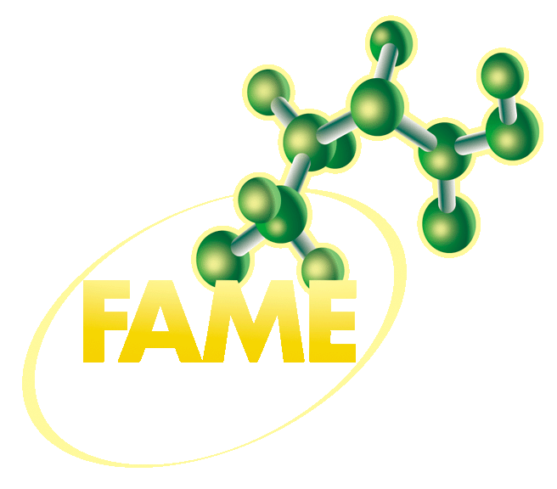**FAME is our product line dedicated to applications for biodiesel, a sector in which Chimec has been operating since 1992, in more than 50 different production facilities. Our product range includes antioxidants, flow improvers, biocides, dispersants and specific multifunctional packages, all developed for the treatment of biodiesel produced both from vegetable oils and animal fats. Please contact us for further details. (**inserire [fueladditives@chimec.it](mailto:fueladditives@chimec.it)come email di contatto**)**

INNOVATIVE SOLUTIONS

**Sulfafree**

**Sulfafree is our H2S scavenger line, specifically developed for the treatment of all the petroleum derivates from LPG to Bitumen. (Read more)**It includes several chemicals formulated to guarantee a fast and complete reduction of the H2S avoiding any impact on the quality specification and satisfying the most critical requirements in terms of handling and safety. As a part of our well known service, our technicians will be responsible for the success of the treatment, choosing the proper additive and defining with our client the best injection and monitoring procedure. **(testo NON in grassetto è presente solo nella pagina dedicate che si apre cliccando su read more)**

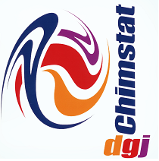***Chimstat (LOGO)***

**Chimec line of fully organic anti-static additives. It guarantees an improvement of the safety conditions during the storage and transport of ULS fuels. *Chimstat* product line is absolutely metal-free, thereby meeting the requirements of vehicle manufacturers which prohibit the use of metallorganic additives.**

**Bacsperse (carattere downlink)**

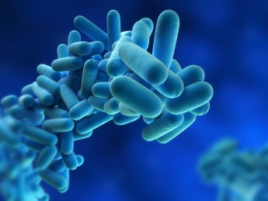**A range of biocides and biodispersants developed to solve all the problems caused by the microbiological contamination of fuels, in particular gasoil/biodiesel blends.(Read more)**

Our Bacsperse line includes additives specifically developed for the application in tank farms and service stations with a proven record of effectiveness on a broad range of contamination sources. In refineries and depots our additives guarantee a fast reduction of the typical consequences of microbiological contamination, including filter blocking and rupture. In the filling stations the efficiency of our treatment allowed our clients to use it as a real alternative to the mechanical maintenance.

The product line is completed by the high level of service and support Chimec can provide in terms of treatment set-up and monitoring. **(testo NON in grassetto è presente solo nella pagina dedicate che si apre cliccando su read more)**

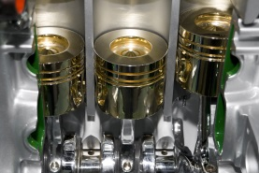**Organic Octane Booster**

**Chimec developed for its customers a new generation of  Performance Packages based on Metal-Free Octane Boosters, which satisfy the strictest technical and environmental specifications of the automotive industry (Read more)**

Our Fully Organic Octane Boosters are effective on any type of gasoline, from the simple ones to the racing fuels already characterized by high RON values. The excellent response and the absence of any impact on gasoline specifications, even at high dosages, make our products an extremely flexible tool suitable for several applications, from the fast correction of out-of-spec batches, to the upgrade of low octane grade gasoline and the production of special fuels.

Our portfolio includes both Octane Boosters and specific Fuel saving Multifunctional packages, which can be tailor made on the needs of our client in terms of performance and savings. **(testo NON in grassetto è presente solo nella pagina dedicate che si apre cliccando su read more)**

**Chimsave**

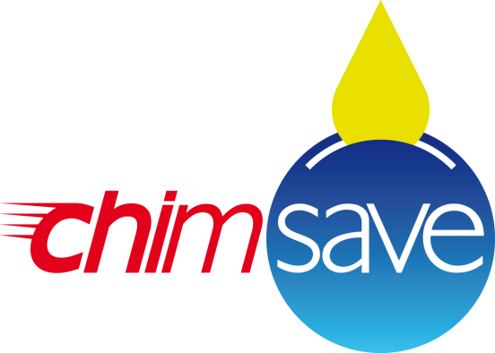**A complete line of performance packages for gasoline, diesel and heating oil. Our *Chimsave* line is Chimec answer to the most recent requirements of the market in terms of fuel saving and emission reduction. (Read more)**

Our base formulations may be customized according to our client’s requirements in terms of detergency, fuel save properties and engine protection.

The effectiveness of our treatments has been certified and verified by independent laboratories through specific laboratory and field tests. **(testo NON in grassetto è presente solo nella pagina dedicate che si apre cliccando su read more)**

**360**

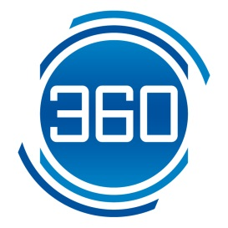**CHIMEC 360 is a line of complex multifunctional packages specifically developed to improve at 360 degrees the fuel quality, guaranteeing benefits in terms of stability, operability and consumption. (Read More)**

Each additive was formulated based on our long term experience in dealing with the typical issues of the final users as well as their needs in terms of consumption reduction. The 360 line includes additives for Diesel, Off-road gasoil and Heating Oil. **(testo NON in grassetto è presente solo nella pagina dedicate che si apre cliccando su read more)**

**EP (LOGO)**

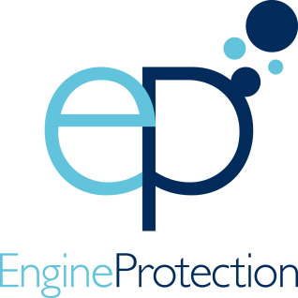**CHIMEC EP line (Engine Protection) represents the most recent development in the fuels sector in terms of fuel injection system detergency.(Read more)**

All the products included in this line were developed to meet even the most stringent detergency requirements and guarantee the best performances also on the latest generation engines.

The use of CHIMEC EP additives provides the optimal operative conditions as they reduce those phenomena causing a gradual increase of toxic emissions, black smoke, noise and, last but not least, fuel consumption.

The highly performing DCA (Deposit Control Additives) are the core of EP line products, but they are also combined with a series of other components that make these additives real multifunctional packages, complete and effective in their wide protective action. **(testo NON in grassetto è presente solo nella pagina dedicate che si apre cliccando su read more)**